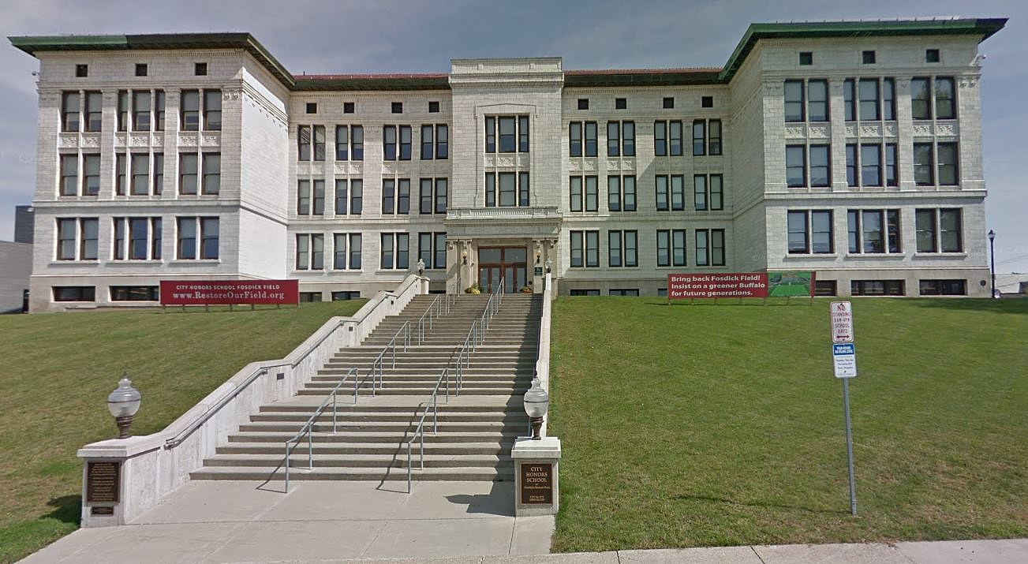

MINIMUM CAPACITY :-

The Minumum intake capacity

of students is between 150-350

children

LIBRARY :-

The Libarary is Available.

CANTEEN:-

The Canteen Facility is Available.

BOARDING :-

No availablility of boarding.

SPORTS :-

There are different categories

sports available.

Girls Volleyball

Boys Volleyball

Football

|  |  |  |
| --- | --- | --- |
| CITY HONORS PS 195  BUFFALO - SCHOOL |  |  |
|  |  |  |
| School Detail :- City Honors School at Fosdick-Masten Park, known colloquially as City Honors, or CHS, is a college preparatory school in Buffalo, New York, United States. It is part of the Buffalo Public Schools system.  P.S. 195 - City Honors School is a highly rated, public, magnet school located in BUFFALO, NY. It has 1,073 students in grades 5-12 with a student-teacher ratio of 13 to 1. According to state test scores, 90% of students are at least proficient in math and 87% in reading. |  |
|